A Project Report on



Dissecting the Digital Landscape:

A Comprehensive Analysis Of Social Media

**Bachelor of Technology**

**In**

**ELECTRONICS AND COMMUNICATION ENGINEERING**

by

**TEAMLEADER P. VYSHNAVI TEAM MEMBER V.NISSI TEAM MEMBER S.PRINCY**

**TEAM MEMBER R.CHAITANYA**

Under the Guidance of

# DR.B.SASHI KANTH

**Associate Professor Department of ECE VIEW, Visakhapatnam**

## Department of Electronics and Communication Engineering

**VIGNAN’S INSTITUTE OF ENGINEERING FOR WOMEN**

**(Approved by AICTE, Affiliated to JNTU-GV, Vizianagaram)**

**Kapujaggarajupeta, VSEZ(P.O), Visakhapatnam -530049**

**2023-24**

# ABSTRACT

This paper presents the report of a social media analytics (SMA) review. The review conducted to find out the methods and tools used in social media analytics, types of social media platforms which the SMA are performed and the field which SMA has been performed. Social media contains a lot of user uploaded data in different formats like text, images, photos, video etc. These large volumes of data are converted in meaningful information which can be understood using different methods and tools which are called social media analytics. A literature review of articles published between 2010-2020 has been conducted using articles obtained from reputable databases IEEE Xplore, ACM digital, Emerald insight, Springer Link and Science direct. A number of 44 articles have been selected for review from 110 retrieved papers. The paper has been reviewed according to the study objectives. The study found that SMA tools and techniques which have been used are sentiment analysis, youtube analytics, visible intelligence, IBM Watson tool and predictive models. The social media platforms which were mostly used are twitter, facebook, youtube, trip advisor and blogs. SMA has been observed in different fields like agriculture, politics, health, social and business sector.

## Contents

**Abstract Contents**

**CHAPTER 1: INTRODUCTION**

* 1. Overview
     + A brief description about project**. CHAPTER 2 :LITERATURE REVIEW**
     + Existing problem
     + Existing approaches to solve the problem
     + .Proposed solution.

**CHAPTER 3 : EXPERIMENTAL RESULTS**

* + - Final output of the project

**CHAPTER 4: ADVANTAGES/ APPLICATIONS**

* + - Advantages and Disadvantages.Applications.

**CHAPTER 5: CONCLUSION**

* + - Conclusion summarizing the entire work..

## CHAPTER 1 INTRODUCTION

**1.1 Overview**

Dissecting the Digital Landscape:

A Comprehensive Analysis of Social Media" is a research article or paper that provides a detailed and in-depth analysis of various social media platforms, including Facebook, Twitter, Instagram, YouTube, and LinkedIn. The analysis covers a wide range of topics related to social media, such as the history and evolution of social media, the demographics of social media users, the impact of social media on communication and society, the role of social media in politics and activism, and the challenges and opportunities of social media for businesses and organizations. The paper draws on a wide range of research studies, surveys, and data sources to provide a comprehensive overview of the digital landscape and its implications for individuals, organizations, and society as a whole. Overall, the paper aims to provide a comprehensive and up- to-date understanding of the complex and dynamic world of social media(twitter as an example), and to inform future research, policy, and practice in this rapidly evolving field.

## CHAPTER 2

**LITERATURE REVIEW**

**Existing Problem**

Organizations are increasingly interested in their social media profile, and can derive insights into how they are perceived through analysis and classification. Twitter has become one of the top social media platforms for news, information, and interaction with brands and influential figures around the world. Therefore, it is no surprise that companies consider this micro blogging platform an essential channel for their marketing strategy and also, to provide customer service. Analysis of Twitter data can help companies obtain qualitative insights to understand how people are talking about their brand**.**

# Proposed Solution

An application is build which subscribes to a Twitter feed that is configured by the user. Each tweet received is analyzed for emotional tone and sentiment. The information is presented in a Web UI as a series of graphs and charts.

We make use Node-red to build Dashboard and sentiment node to see the sentiment of tweets and displays the number of positive tweets and negatives that a hashtag has using line charts

## CHAPTER 3 EXPERIMENTAL RESULTS

**Final Output**

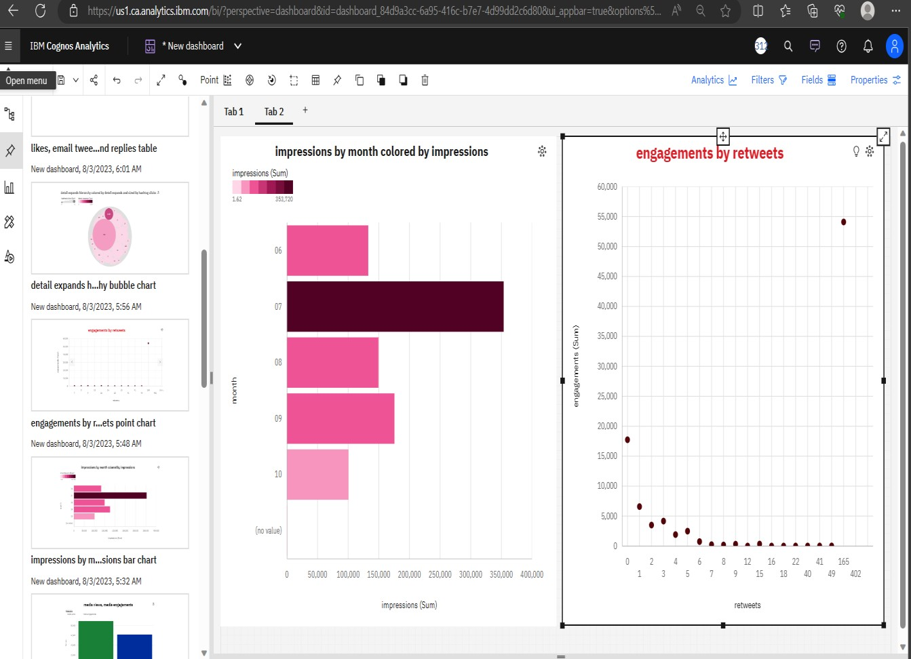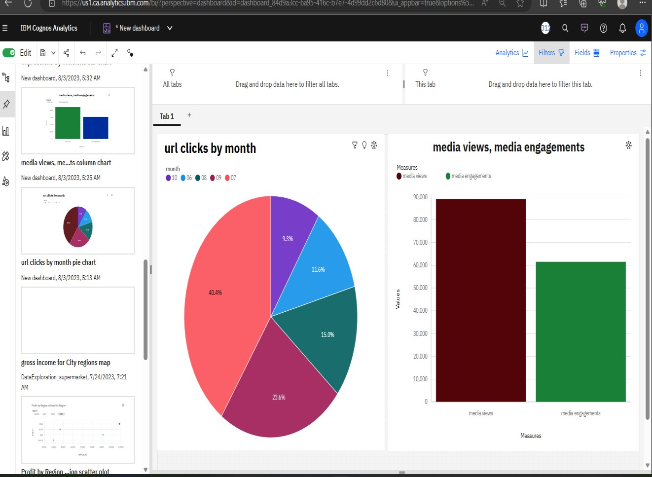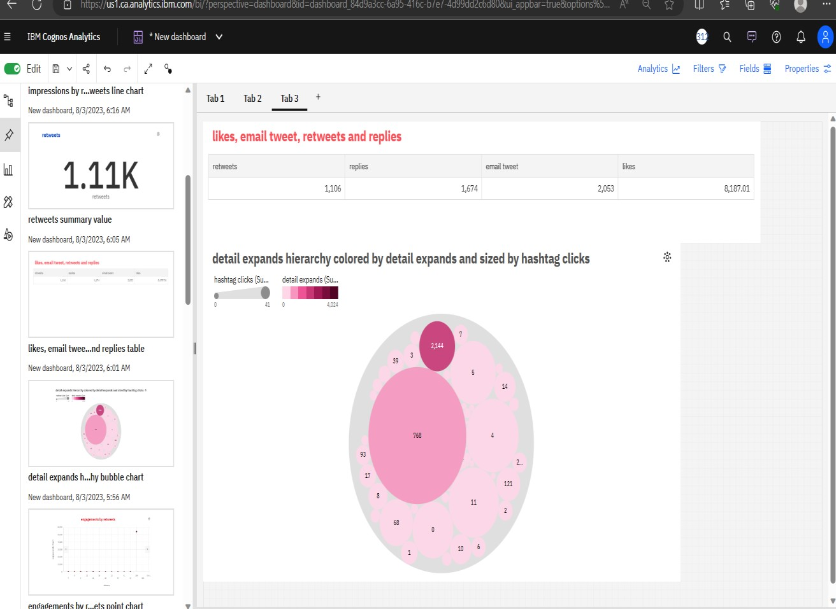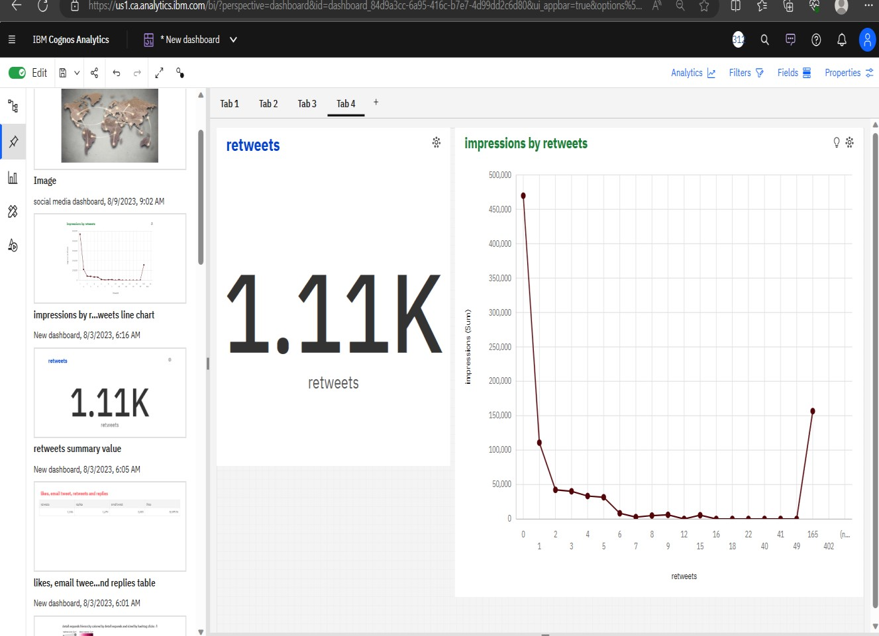

## CHAPTER 4 ADVANTAGES/ APPLICATIONS

**Advantages and Disadvantages**

# Advantages:

Due to its advantages this SMA has to be performed in a good and manageable way so that the results can be of high advantages. For future uses further recommendations are for studies to be conducted which will give the frameworks for implementation and management of SMA process in different applications eg, business, politics, health etc.

* improving customer service and market research on social channels
* Investing smarter in product development and marketing
* Increasing competitive intelligence and social media ROI
* Spotting patterns and trends related to products and brands

# Disadvantages:

* The unstructured, unprompted nature of social media conversations means the data might not include the information and insights organizations are looking for.
* The quality and amount of data may not be consistent.
* Social media is generally not useful for in-depth feedback.
* Many socially popular people may promote competition or provide negative feedback on the company, which could sway the public’s perception of the brand.
* Missing data, dark data, irrelevant data and noisy data could also prove to be a disadvantage while analyzing data.
* Completing work tasks after leaving the office.
* Platforms changing constantly.

**APPLICATIONS**

* + Social media analytics applications have potential in several health services, according to literature there are some studies explaining this well, Kannan et al. (2018) introduced the study using topic discovery and contents analysis in twitter platform to determine the information about Dengue fever shared in twitter. Culotta (2010) introduces the study which uses predictive analysis to predict the rate of influenza in a population using twitter messages. The study conducted by Martinez et al. (2019) uses sentiment analysis techniques to get insight on social media e- cigarettes belief and risk perceptions using twitter comments. Another study conducted by Al Kubaizi et al. (2015) analyse the comments on people’s experience about the use of herbs which was advised by the prophet Mohammed (PBUH) the study uses sentiment analysis, natural language processing and other tool like IBM Watson natural understand language to the twitter comments..

**CONCLUSION**

**CHAPTER 5**

The study aims to give information about social media analytics usage from the reviewed articles. Based on the surveyed papers and the objectives of the study the paper contributes to three main areas. First the study identifies different methods and tools used in social media analytics. Different analytics has been demonstrated like sentiment analysis, trend analysis, visual analytics, contents analysis and social network analysis. Reviewed articles show that Sentiment analysis has been more used than other types of analytics. Based on different kinds of analytics also there are different tools, reviewed articles show different tools like Youtube analytics, facebook insight, radian 6, Tweetriz, visible intelligence and IBM Watson. Choosing the tools and analytics method depends on the type of analytics you want to perform and the available data from the social media platform.

The study also contributes to providing types of social media platforms which are used for SMA. Most of the analytics were performed on Twitter. Other platforms were facebook, Youtube, Instagram, Tripadvisor and Flickr. The reviewed analysis shows the usage of SMA from different fields like health, local government, tourism, supply chain, industry, social issues, disaster management, business, media, fashion industry, sports, politics, agriculture, stock market, community development and road safety. SMA has been performed in the business area to analyze data in different business processes like marketing, product review, providing customer segments and gathering other intelligence information. This shows that SMA provides more importance to business organizations and other fields to understand the data from the social media platforms.